# **Research Question** Age and Tech Support: Does The Use of Tech Support Increase With Age?

# Sam Spencer

# Western Governors University

# Abstract

The purpose of this research is to examine the data sets provided and conclude whether or not increase of age has any impact on the need for technological support. With the use of technology becoming more prevalent in everyday life, it could be difficult for some users to keep up without help from external means. While technology continues to evolve, select demographics may not be able to keep up with the ever evolving landscape of technology. According to (Martínez-Alcalá et al., 2018), “As information and services are becoming more and more decentralized and they are often available in the cloud, an increasing number of older adults are expected to use Internet-based services—health, education, finance and others”. This creates a disconnect, and my goal is to determine if this disconnect causes an increase of tech support use. **A1. Identify which data from the original data set and the add-on CSV file are needed to answer the research question.**

The required data sets are:

From the services table: customer_id (the primary key) and TechSupport. Below is a snippet of the csv document that i’ll be using, services

| customer_id | InternetService | Phone | Multiple | OnlineSecurity | OnlineBackup | DeviceProtection | TechSupport |
| --- | --- | --- | --- | --- | --- | --- | --- |
| A00088 | Fiber Optic | Yes | Yes | Yes | No | No | No |
| A04204 | DSL | Yes | Yes | Yes | Yes | Yes | Yes |
| A04378 | None | Yes | Yes | No | No | No | Yes |
| A04830 | DSL | Yes | Yes | Yes | No | Yes | No |
| A05946 | Fiber Optic | No | No | No | No | No | No |
| A06667 | DSL | Yes | Yes | No | Yes | Yes | Yes |
| A08755 | Fiber Optic | Yes | No | No | Yes | Yes | Yes |
| A100934 | DSL | Yes | No | Yes | No | No | No |

From the customer: customer_id (primary key/foreign key) and age. Below is a snippet of the customer csv file.

| *customer_id* | *lat* | *lng* | *population* | *children* | *age* |
| --- | --- | --- | --- | --- | --- |
| *K409198* | *56.251* | *-133.37571* | *38* | *0* | *68* |
| *S120509* | *44.32893* | *-84.2408* | *10446* | *1* | *27* |
| *K191035* | *45.35589* | *-123.24657* | *3735* | *4* | *50* |
| *D90850* | *32.96687* | *-117.24798* | *13863* | *1* | *48* |

1. **Create a logical data model for the add-on CSV file by evaluating the data contained in the file and emphasizing the relational constraints.**

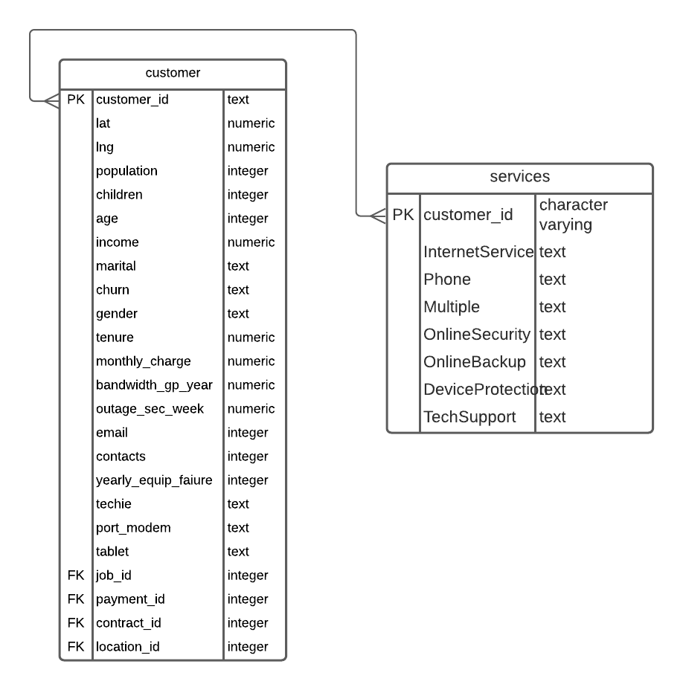

B1. This code loads and creates the table.

| CREATE TABLE "services" (  "customer_id" character varying,  "InternetService" text,  "Phone" text,  "Multiple" text,  "OnlineSecurity" text); |
| --- |

B2

| CREATE TABLE "customer" (  "customer_id" text,  "lat" numeric,  "lng" numeric,  "population" integer,  "children" integer,  "age" integer,  "income" numeric,  "marital" text,  "churn" text,  "gender" text,  "tenure" numeric,  "monthly_charge" numeric,  "bandwidth_gp_year" numeric,  "outage_sec_week" numeric,  "email" integer,  "contacts" integer,  "yearly_equip_faiure" integer,  "techie" text,  "port_modem" text,  "tablet" text,  "job_id" integer,  "payment_id" integer,  "contract_id" integer,  "location_id" integer,  PRIMARY KEY ("customer_id") ); |
| --- |

**C. Write SQL statement(s) for a query or queries that inform the research question summarized in part A.**

| select count(*)  from services  where techsupport = 'Yes'; -- 3750    select count (*)  from customer, services  where customer.customer_id = services.customer_id  and age >= 65; -- 3380 90% |
| --- |

| SELECT * FROM services  SELECT * FROM customer  SELECT c.customer_id, c.age, s."TechSupport" FROM customer as c FULL OUTER JOIN services as s on c.customer_id=s.customer_id |
| --- |

C1. 1. Provide a CSV file or files that capture the results from the query or queries.

They will be attached.

**D. Determine how often the add-on file should be acquired and refreshed in the database for the data to remain relevant to the business and the research question.**

According to the US based senior citizen advocacy group [AARP (2019)](https://arc.aarpinternational.org/countries/united-states), “ Every day in the United States, 10,000 people turn 65, and the number of older adults will more than double over the next several decades and represent over 20 percent of the population by 2050”. Given these statistics, you can conclude that, in order to remain relevant to business needs, data needs to be obtained daily, since the number of individuals turning 65 increases by 10,000 each day, the potential for tech support increases with it, since 91% of individuals 65+ have a need for it. Furthermore, according to the [Profile of Older Americans](https://acl.gov/sites/default/files/Aging%20and%20Disability%20in%20America/2020ProfileOlderAmericans.Final_.pdf) (2021), individuals 65+ are estimated to account for 21.6% of the US population by 2040 (p. 3).

**E. Create an SQL script that performs the process of loading the add-on data.**

| **--command " "\\copy public.services (customer_id, \"InternetService\", \"Phone\", \"Multiple\", \"OnlineSecurity\", \"OnlineBackup\", \"DeviceProtection\", \"TechSupport\") FROM 'C:/Users/LabUser/Desktop/Services.csv' DELIMITER ',' CSV HEADER QUOTE '\"' ESCAPE '''';""** |
| --- |

**F. Provide a Panopto video recording that includes a demonstration of the functionality of the code used for the analysis and a summary of the programming environment.**

It will be attached

**G. Record the web sources used to acquire data or segments of third-party code to support the application. Be sure the web sources are reliable.**

All web sources are included on the final page, sources.

**H. Acknowledge sources, using in-text citations and references, for content that is quoted, paraphrased, or summarized.**

In text sources have been cited throughout the document when applicable.

# Sources

*United States population (live)*. Worldometer. (n.d.). Retrieved November 14, 2021, from https://www.worldometers.info/world-population/us-population/.

2020 PROFILE OF OLDER AMERICANS. 2020 Profile of Older Americans (PDF). (2021, May). Retrieved November 13, 2021, from <https://acl.gov/sites/default/files/Aging%20and%20Disability%20in%20America/2020ProfileOlderAmericans.Final_.pdf>.

AARP. (2019). *The Aging Readiness & Competitiveness Report*. United States. Retrieved November 14, 2021, from https://arc.aarpinternational.org/countries/united-states.

# Appendix

Each Appendix begins on a new page. Microsoft Word® has an “insert page break” feature that can assure the section begins on a new page even if changes are made to the sections prior to it.

# Footnotes

1Complete APA style formatting information may be found in the Publication Manual.

Table 1

*Type the table text here in italics; start a new page for each table*

[Insert table here]

# Figure Captions

*Figure 1.* Caption of figure

# [Figures – note that this page does not have the manuscript header and page number]